**Gustavo Hideo H. Correa**

**CS450**

**Neural Networks**

**Source Code**

<https://github.com/gustavo-hideo/IntoData/blob/master/Projects/Stocks%20predictor%20-%20in%20progress/in%20progress%20-%20gustavo.py>

**Approach**

Experimentation.

I used **KERAS** and **LSTM** (Long Short Term Memory) for the NN model.

My libraries for wrangling the data and preparing the train and test datasets were **PANDAS**, **NUMPY** and **FASTAI** (create date features).

The dataset I extracted using a **QUANDL API**.

**Challenges**

The hardest part of the work was to prepare the data to be used with the neural networking model, mostly to understand how the shape needs to be, and to normalize the data.

I used examples and tutorials in the internet to learn how to shape the data.

**Results**

Dataset

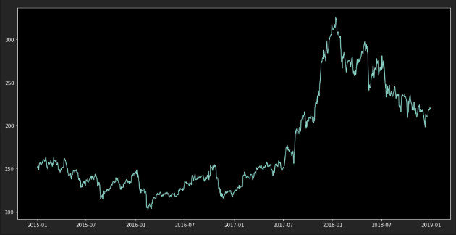

**RMSE**: 1.27

Prediction (white line):

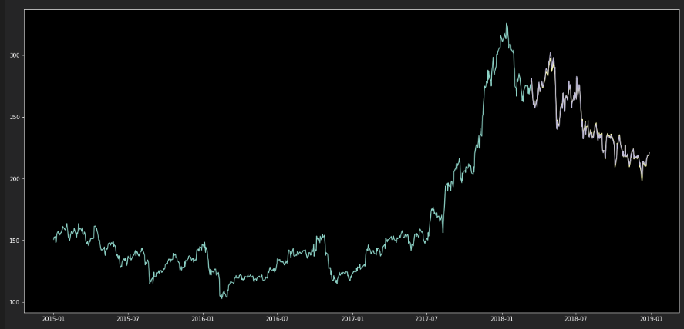

**Assessment**

4) Meets requirements

5) Data wrangling.